**ASSIGNMENT- 2**

|  |  |
| --- | --- |
| Assignment Date | 27 September 2022 |
| Student Name | SEDHURAGAVAN L |
| Student Roll Number | 73771921190 |
| Maximum Marks | 2 Marks |

**Question-1:**

* Create a Flask App
* Add the Home page, About Page
* Add the Bootstrap
* Add the Sign in page and App the Signup Page

|  |  |
| --- | --- |
| **Solution:** |  |
| **app.py:** | from flask import Flask,render_template,request,url_for,redirect,flash from markupsafe import escape  app=Flask( name__) @app.route("/")  def index():  return render_template("home.html")  @app.route("/home.html") def hello():  return render_template("home.html")  @app.route("/about.html") def profile():  return render_template("about.html")  @app.route("/signup.html") def signup():  return render_template("signup.html")  @app.route("/signin.html") def signin(): |

**Templates: Home page**

**Base page**

<!-- <link rel="stylesheet" href="{{url_for('static', filename='css/style.css')}}"> -->

{% block head%}{% endblock %}

</head>

<body>

<nav class="navbar navbar-expand-lg navbar-light bg-light">

<div class="container-fluid">

<a class="navbar-brand" href="#">Navbar</a>

<button class="navbar-toggler" type="button" data-bs- toggle="collapse" data-bs-target="#navbarSupportedContent" aria- controls="navbarSupportedContent" aria-expanded="false" aria-label="Toggle navigation">

<span class="navbar-toggler-icon"></span>

</button>

<div class="collapse navbar-collapse" id="navbarSupportedContent">

<ul class="navbar-nav me-auto mb-2 mb-lg-0">

<li class="nav-item">

<a class="nav-link active" aria-current="page" href="home.html">Home</a>

</li>

<li class="nav-item">

<a class="nav-link" href="signin.html">signin</a>

</li>

<li class="nav-item">

<a class="nav-link" href="signup.html">signup</a>

</li>

<li class="nav-item">

<a class="nav-link" href="about.html">about</a>

</li>

<li class="nav-item dropdown">

<a class="nav-link dropdown-toggle" href="#" id="navbarDropdown" role="button" data-bs-toggle="dropdown" aria- expanded="false">

Dropdown

</a>

<ul class="dropdown-menu" aria- labelledby="navbarDropdown">

<li><a class="dropdown-item" href="#">Action</a></li>

<li><a class="dropdown-item" href="#">Another

action</a></li>

here</a></li>

<li><hr class="dropdown-divider"></li>

<li><a class="dropdown-item" href="#">Something else

**About page**

**Signin page**

**Signup page**

**Output**

**Homepage:**

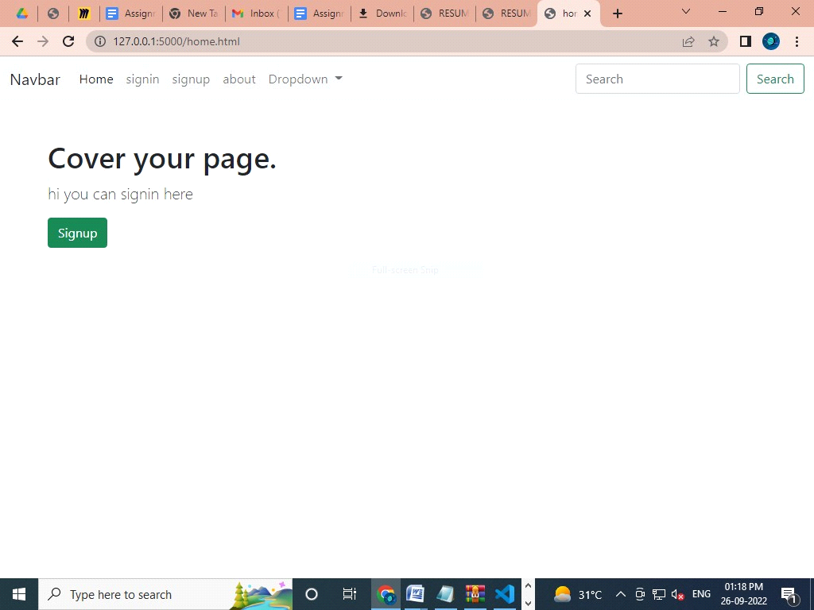

**Signin page:**

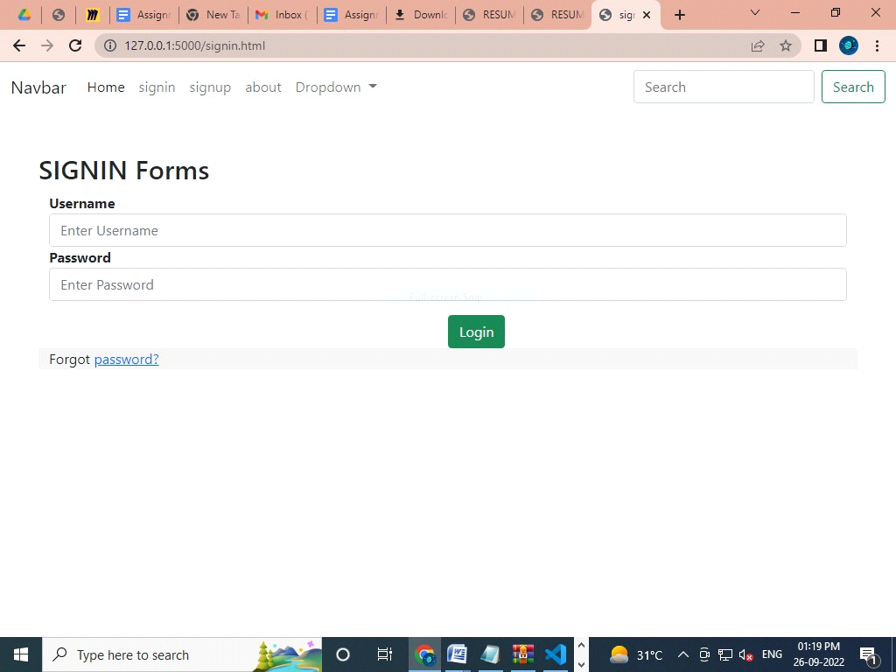

**signup page:**

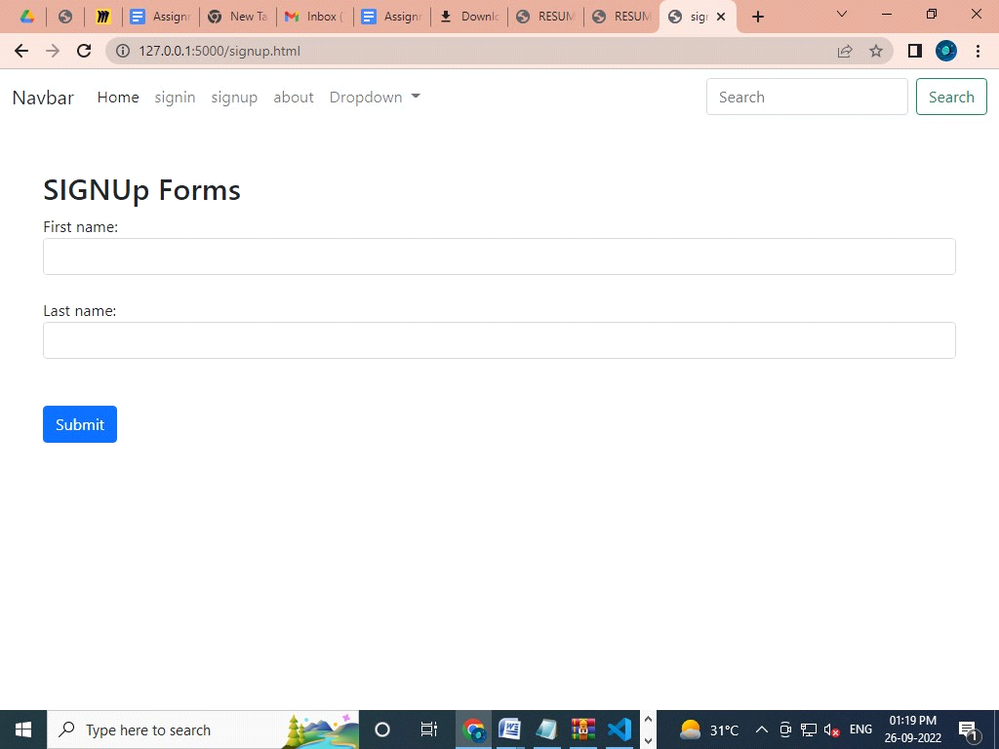

About page:

